1420/01/01
1420/12/29

1320/1/1
1320/12/29
1320/1/30

20170701
year(4)/Month(2)/day(2) m? minute
M:
Date.ToText([Miladi], "yyyyMMdd")

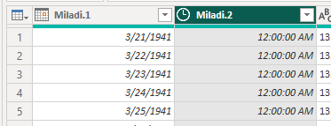
3/21/1941

